Aidan Brophy, Evan Mowry

ENGLIT 1201

Game Design Project — Final Reflection

Our Unity game is an adaptation of an adaptation—it’s based off of the final act of the pop-up book version of Stephen King’s *The Girl Who Loved Tom Gordon*, or TGWLTG for short. Summing it up quickly, the story follows a young girl’s struggle to survive and make her way back to civilization after getting incredibly lost in the woods, aided by hallucinations of her favorite baseball player, Tom Gordon, and hounded starvation, the elements, and eventually a black bear she believes to by “the God of the Lost,” (King and Moerbeek). Although this pop-up book adaptation is—technically speaking—a children’s book, you can probably tell just from that brief summary that the story within is about as heavy as one would expect from Mr. King. It was for this reason that, going into the process of formulating our own adaptation, we knew that certain types of games wouldn’t feel ‘right’ in more ways than one.

A Mario-style 2D side-scrolling platformer was considered, but the idea was quickly discarded—we didn’t feel like we could give the story we were adapting the right feel and/or weight with such a format, it just didn’t feel ‘serious’ enough. A hidden object game involving scavenging for food never even made it off the ground, nor did a top-down shooter where the player would throw Walkmans at black bears. The alternative we decided on was a (relatively) simple maze game, something like Pac-Man, or more appropriately to our project, any number of maze-based horror games one can find on places like itch.io or Newgrounds, and we went with this type of game for a number of reasons. Not only did we feel like a timed maze runner was open-ended enough as a game format for us to tell this part of the story with the right level of seriousness and intensity, but also this format would be relatively simple to build—all we needed was a maze, a player character, the ability to move that character, a countdown timer, and a way to stop that timer upon escaping the maze. That would be the easy part, we thought, and from there we may be able to expand. And we did have ideas for expanding—we thought that having a black bear (the God of the Lost from the story) begin to chase the player through the maze after a decent head start was entirely feasible, especially given the fact that Unity offers an in-depth tutorial explaining exactly how to use navmeshes and AI pathfinding for free (Getting Started With AI Pathfinding - Unity Learn). Despite our thematic departure, Pac-Man was a heavy influence early on (*Pac-Man*).

We had a number of ideas that we ended up not having the time, patience, or ability to implement. Throughout production, we made jokes about having .pngs of Tom Gordon himself appear and disappear around the player, as a nod to the hallucinations of Tom Gordon which feature frequently within the book. Additionally, our early idea of having an AI black bear chase the player through the maze never came to fruition. Issues arose from multiple sources, including character animations, misunderstandings of the layer system, finish line functionality, and the exact usage of the GameObject Brush within the Tile Palette. However, for almost all of the problems we encountered, we found a way through or around—but overcoming those hurdles are something to be explained in our own personal reflections.

Our final build is more or less how we envisioned it during the brainstorming process: A player makes their way through a maze of trees, trying to reach the hunter on the road—as occurs in the story—before a timer runs out, and if the player succeeds, they’re shown a victory screen. It’s meant to be serious and tense, and maybe it doesn’t quite pull that off—without an AI black bear, the only real source of tension is the ever-ticking timer, and there is a bit of an incongruence between the spooky music we quickly implemented and the fact that the scene(s) within the book that we modeled our maze off of take place in the mid-morning of a bright and sunny day—but it's the thought that counts. Accessibility may be an issue in some cases, given the fact that keyboard input is required for movement, but it's possible that could be fixed by affected players via input rebinding. And moreover, if our game has an accessibility issue in its user input requirements, then based on the games displayed on the demo days, it seems as though almost every other team would have the same issue! However, given how rushed or ramshackle our development process felt at times, I was surprisingly happy with how our game stood alongside the others exhibited in class last week.

As for ideas for future improvement, we both have our own thoughts which we may or may not expand upon in our personal reflections. But I think we can both agree that having a black bear would make this game *that* much cooler. And, of course, some smoother movement, smoother transitions, a more cohesive art style—the list goes on for a decent while.

References

“Getting Started With AI Pathfinding - Unity Learn.” Unity Learn, learn.unity.com/project/beginner-ai-pathfinding?uv=2017.3. Accessed 18 Mar. 2024.

King, Stephen, and Kees Moerbeek. The Girl Who Loved Tom Gordon: A Pop-up Book. Little Simon, 2004.

*Pac-Man*. Directed by Toru Iwatani, Namco, 1980. Arcade game.

Appendix

Hurdle Tracker Doc: [ENGLIT 1201 Game Design Project Hurdles](https://docs.google.com/document/d/1LaCIdntSZkbmhHobGp91LxB5NEjo_rtEtamFi4-2QDo/edit?usp=sharing)

Github Repo: <https://github.com/APBCh33se22/ENGLIT-1201-Game-Design-Project>

Information Architecture Web: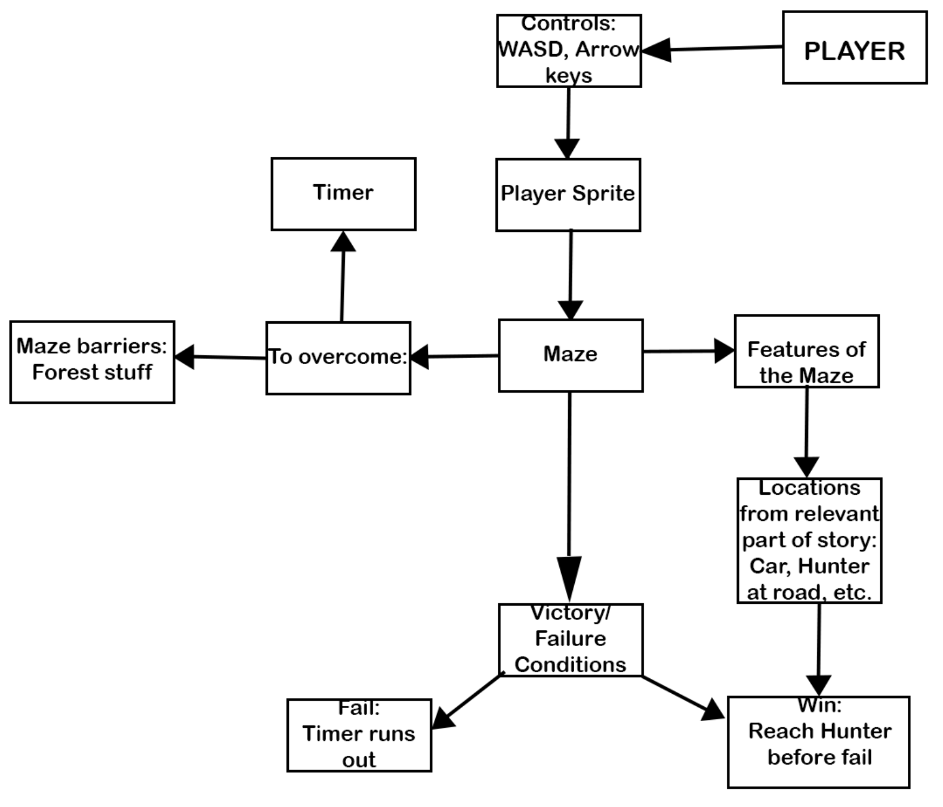

Wireframe: